

**YAŞAR UNIVERSITY**

**FACULTY OF ENGINEERING**

**DEPARTMENT OF COMPUTER ENGINEERING**

**COMP4920 Senior Design Project II, Spring 2020**

**Advisor: Mehmet Ufuk Çağlayan**

**POF: Performance Optimized Fluid System**

**Final Report**

**(Bachelor of Science Thesis)**

**By:**

**Baran Budak -15070001012**

**Cihanser Çalışkan -16070001020**

**İsmail Mekan -15070001048**

# Revision History

|  |  |  |
| --- | --- | --- |
| **Revision** | **Date** | **Explanation** |
| 1.0 | 8.12.2019 | Initial Final Report. |
| 1.1 | 10.2.2020 | - Abstract and Özet part renewed.  - Revision history added. |
| 1.2 | 17.2.2020 | Warning page added. |
| 1.3 | 2.3.2020 | Introduction section writings updated. |
| 1.4 | 7.3.2020 | 2. semester Gantt chart updated. |
| 1.5 | 15.2.2020 | Requirements section added. |
| 1.6 | 5.3.2020 | Class diagram and description is updated. |
| 1.7 | 18.3.2020 | Code parts and explanations updated in implementation section. |
| 1.8 | 30.3.2020 | Performance test and results added. |
| 1.9 | 14.4.2020 | - Cost analysis of second semester added.  - Plagiarism statement updated. |
| 2.0 | 27.4.2020 | - Appendices of product manual added.  - Table of contents updated.  - List of figures updated.  - List of tables updated. |

# PLAGIARISM STATEMENT

This report was written by the group members and in our own words, except for quotations from published and unpublished sources which are clearly indicated and acknowledged as such. We are conscious that the incorporation of material from other works or a paraphrase of such material without acknowledgement will be treated as plagiarism according to the University Regulations. The source of any picture, graph, map, or other illustration is also indicated, as is the source, published or unpublished, of any material not resulting from our own experimentation, observation or specimen collecting.

**Project Group Members:**

|  |  |  |  |
| --- | --- | --- | --- |
| **Name, Last name** | **Student Number** | **Signature** | **Date** |
| Baran Budak | 15070001012 |  | 24.05.2020 |
| Cihanser Çalışkan | 16070001020 |  | 24.05.2020 |
| İsmail Mekan | 15070001048 |  | 24.05.2020 |

**Project Supervisors:**

|  |  |  |  |
| --- | --- | --- | --- |
| **Name, Last name** | **Department** | **Signature** | **Date** |
| Mehmet Ufuk Çağlayan | Computer Engineering |  |  |

# ACKNOWLEDGEMENTS

We would like to express our most sincere thanks to Asst. Prof. Dr. Gizem Kayar for guidance and suggestions in the project. Also, we thank our supervisor Prof. Dr. Mehmet Ufuk Çağlayan for his efforts in the project. This project is supported by Yaşar University Computer Engineering Department.

# KEYWORDS

|  |  |
| --- | --- |
| **Term** | **Description** |
| Cell | Axis aligned bounding box is divided into small identical cubes. |
| Colour field quantity | It is a functionthat calculates how each particle is affected by all the other particles. |
| Gradient | The directional derivative of a scalar field gives a vector field directed towards where the increment is most, and its magnitude is equal to the greatest value of the change. |
| Grid | Series of vertical and horizontal lines that are used to subdivide AABB vertically and horizontally into cells in three-dimensional space. |
| Iso-surface | An isosurface is a 3D surface representation of points with equal values in a 3D data distribution which is the 3D equivalent of a contour line. |
| Marching Cubes | Marching cubes is a computer graphics algorithm, published in 1987 for extracting a polygonal mesh of an isosurface from a three-dimensional discrete scalar field. |
| NVIDIA Flex | NVIDIA Flex is a particle-based simulation technique for real-time visual effects created by NVIDIA company. |
| Polygonal Mesh | A polygon mesh is the collection of vertices, edges, and faces that make up a 3D object. |
| Unity 3D | Unity is a cross-platform game engine developed by Unity Technologies. Unity is used for developing video games and simulations for consoles and mobile devices. |
| Spatial Hashing | Spatial hashing is a technique in which objects in a 2D or 3D domain space are projected into a 1D hash table allowing for very fast queries on objects in the domain space. |

**Table 1:** Keywords

# ABSTRACT

POF system aims at providing more optimized and faster surface identification and visualization on particle-based fluid simulations.

This project is research-based. It is possible for the small parts of the structures can change during the project. We research possible solutions for the problem and examined a lot of research papers for the algorithms. We discussed the pros and cons of various methods and decided to use specific algorithms for the mentioned reasons.

The POF system divided into a structure that has various algorithms. A control panel (controller or handler) administers these algorithms that placed as substructures in the POF system.

We can list these substructures as Hash System, Surface Particle Recognizer and Visualization parts. Hash System is an imaginary structure and serves to search for data easily. Surface particle recognizer distinguishes the surface particles. Visualization part draws the surface particles vertices which is an implementation of the Marching Cubes algorithm [4].

# ÖZET

POF sistemi, partikül bazlı sıvı simülasyonlarında daha optimize ve daha hızlı yüzey tanımlama ve görüntüleme sağlamayı amaçlamaktadır.

Bu proje araştırmaya dayalıdır. Proje sırasında yapıların küçük bölümlerinin değişmesi mümkündür. Sorun için olası çözümleri araştırdık ve algoritmalar için birçok araştırma makalesini inceledik. Çeşitli yöntemlerin artılarını ve eksilerini tartıştık ve belirtilen nedenlerden dolayı spesifik algoritmalar kullanmaya karar verdik.

POF sistemi, çeşitli algoritmalara sahip bir yapıya ayrılmıştır. Sistemin arayüzü olan bir kontrol paneli, (denetleyici veya işleyici) POF sistemindeki alt bileşenleri yönetir.

Bu alt yapıları karma sistemi (hash system), yüzey partikül tanıyıcı ve görselleştirme parçaları olarak listeleyebiliriz. Karma (hash) sistemi hayali bir yapıdır ve verileri kolayca aramaya yarar. Yüzey partikül tanıyıcı yüzey partiküllerini ayırt etmemize yarar. Görselleştirme bölümü, Yürüyen Küpler algoritmasının [4] bir uygulaması olan yüzey parçacıklarının köşelerini çizmemizi sağlar.

# TABLE OF CONTENTS

PLAGIARISM STATEMENT 3

ACKNOWLEDGEMENTS 4

KEYWORDS 4

ABSTRACT 5

ÖZET 6

TABLE OF CONTENTS 7

LIST OF FIGURES 8

LIST OF TABLES 8

LIST OF ACRONYMS/ABBREVIATIONS 9

WARNING 10

1. INTRODUCTION 11

1.1. Description of the Problem 11

1.2. Project Goal 11

1.3. Project Output 11

1.4. Project Activities and Schedule 12

1.4.1 First Semester Schedule 12

1.4.2 Second Semester Schedule 13

2. REQUIREMENTS 14

3. DESIGN 15

3.1. High Level Design 15

3.1.1 Class Diagram 15

3.2. Detailed Design 16

3.3. Realistic Restrictions and Conditions in the Design 16

4. IMPLEMENTATION and TESTS 17

4.1. Implementation of the System 17

4.1.1. Problems and Solutions 17

4.1.2. Implementation of Hash Algorithm 17

4.1.3. Particle Neighbour Algorithm 19

4.2. Performance Tests and Results 20

4.3 Environment Testing 24

4.3.1. Availability of the Necessary Environment 24

5. CONCLUSIONS 25

5.1. Summary 25

5.2. Cost Analysis 25

5.2.1 Cost Analysis of First Semester 25

5.2.1.1 Cost of Workers 26

5.2.1.2 Cost of Software 26

5.2.1.3 Cost of Hardware 26

5.2.1.3.1 PC components that used in Project 26

5.2.1.3.2. Optimal Simulation Computer 27

5.2.2 Cost Analysis of Second Semester 27

5.2.2.1 Cost of Workers 27

5.3. Benefits of the Project 28

5.3.1 Animations and Movies 28

5.3.2 Scientific work 28

5.3.3 Games 28

5.3.4 Construction 28

5.4. Future Work 28

References 29

APPENDICES 30

APPENDIX A: REQUIREMENTS SPECIFICATIONS DOCUMENT 31

APPENDIX B: DESIGN SPECIFICATIONS DOCUMENT 47

APPENDIX C: PRODUCT MANUAL 66

# LIST OF FIGURES

Figure 1: Class Diagram 15

Figure 2: Cell ID Numbering 18

Figure 3: Group Struct 18

Figure 4: Hash Size 18

Figure 5: Intersection Boundaries Check 19

Figure 6: Finding Corner Cells 20

Figure 7: Finding Dimensional Cell Count 20

Figure 8: Finding Cell Numbers in Specific Area 20

Figure 9: Particles in Perfect Cube Form 21

Figure 10: Particles on Ramp 22

Figure 11: Particles are Crashing to Obstacles 22

Figure 12: Surface Recognition Time Scale by Frame Chart 23

Figure 13: Surface Recognition by particle number comparison chart 24

# LIST OF TABLES

Table 1: Keywords 4

Table 2: List of Acronyms/Abbreviations 9

Table 3: Requirements List 14

Table 4: Problems and Solutions 17

Table 5: Environment Availability 25

Table 6: 1. Semester Cost of Workers 26

Table 7: Cost of Software 26

Table 8: Cost of PC1 26

Table 9: Cost of PC2 27

Table 10: 2. Semester Cost of Workers 27

# LIST OF ACRONYMS/ABBREVIATIONS

|  |  |
| --- | --- |
| AABB | Axis Aligned Bounding Box. Bounding volume for a set of objects is a closed volume that completely contains the union of the objects in the set. |
| API | Application Programming Interface. |
| CPU | Central Processing Unit. |
| CUDA | Compute Unified Device Architecture. CUDA is a parallel computing platform and application programming interface (API) model created by NVIDIA. |
| D3D11 | Direct3D 11. Is to create 3-D graphics for games and scientific and desktop applications. |
| GPU | Graphic Processing Unit. |
| MVC | Stands for Model View Controller. MVC is an application design model comprised of three interconnected parts (Model, View, Controller). |
| NVIDIA | NVIDIA corporation is a company designs GPUs. |
| OPENGL | Open Graphics Library is a cross-language, cross-platform application programming interface for rendering 2D and 3D vector graphics. |
| POF | Performance Optimized Fluid. |
| SSF | Screen Space Fluids Pro. |

**Table 3:** List of acronyms/abbreviations

**WARNING!**

**Important Note:** POF project has hardware-based requirements. Your GPU must have CUDA 8.0.44 or better version and D3D11 support. If you do not have the required components, POF will not work.

We were using the Yaşar university computer lab in the first semester. Since Yaşar University is closed because of the COVID-19, we cannot access the computer laboratory. Therefore, we cannot make any progress in visualization.

The %75 of the project is finished. Implementation of the Marching Cubes algorithm which is the last step about the visualization part of our project could not be completed (We have a working marching cubes code as a prototype. However, we did not implement to the POF system.). For this reason, we have restated our project requirements and goals which will be clarified detailed in the Final Report and Requirements Specifications Document. In brief, the implementation and testing of the surface recognition system is the new goal of our project and some of the requirements are discarded such as Marching Cubes.

# 1. INTRODUCTION

This section explained in three main titles: problem description, project goal and project output.

# *1.1. Description of the Problem*

The main problem of the particle-based fluid simulation system is excessive numbers of the particles. A particle is a rigid body sphere.

There are millions of particles in a small number of liquids. Simulation control particles by physics-based calculations to obtain fluid behaviours. Simulation having difficulties in calculations dependent on a surplus of particles and time and memory complexity increases indirectly. Visualizing millions of particles on a scene are a tedious job.

# *1.2. Project Goal*

During the POF project, we were researching ways of enhancing the performance and efficiency of particle-based fluid simulation. Creating a suitable and stable platform for executing a particle-based fluid simulation is one of our primary project goals. This platform is Unity for our project. Constructing a more user-friendly platform for testing and comparing various algorithms for scientific research is another project goal.

We aim to achieve these goals by reaching particles faster by constructing a spatial hash sub-system. To detect surface particles, we must implement surface recognition sub-system.

Our project has no predetermined method because POF is a research and development based. We can research and implement new methods during the project.

# *1.3. Project Output*

* Better performance.
* Better memory efficiency.
* Fluid-like appearance and behaviour.
* Different algorithms testing for performance and efficiency.
* Surface particles detection.

# *1.4. Project Activities and Schedule*

***1.4.1 First Semester Schedule***

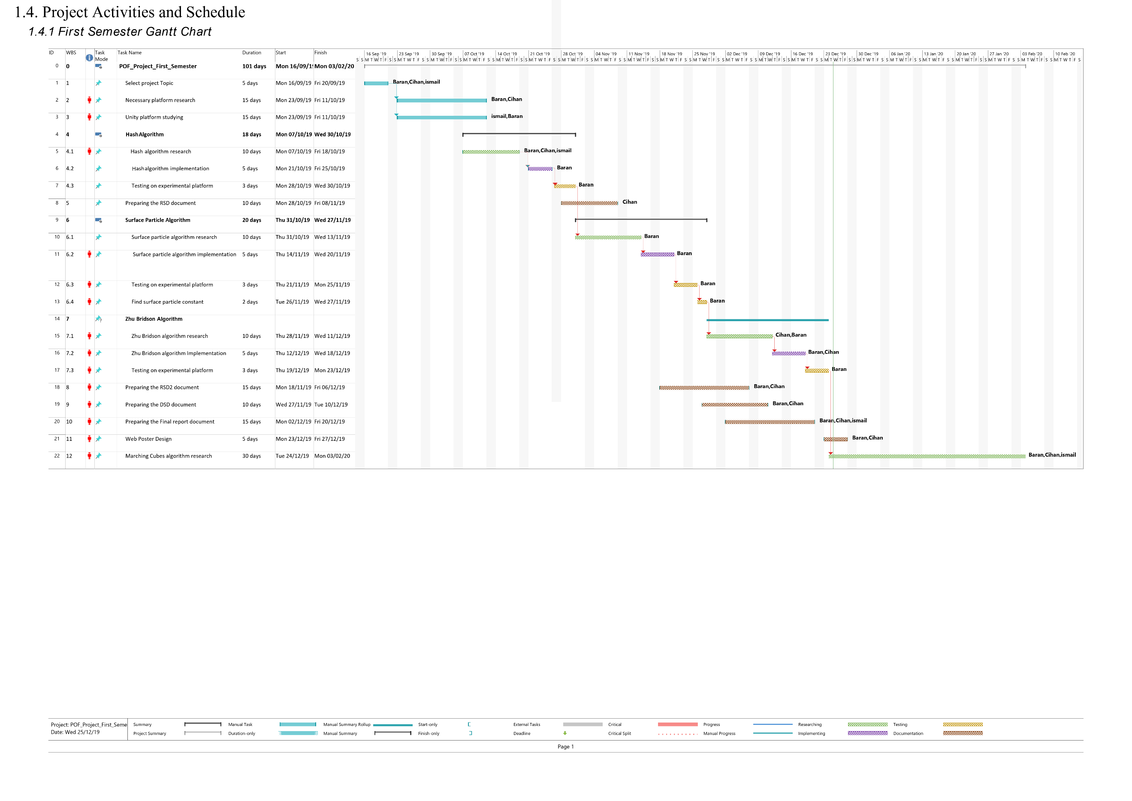

***1.4.2 Second Semester Schedule***

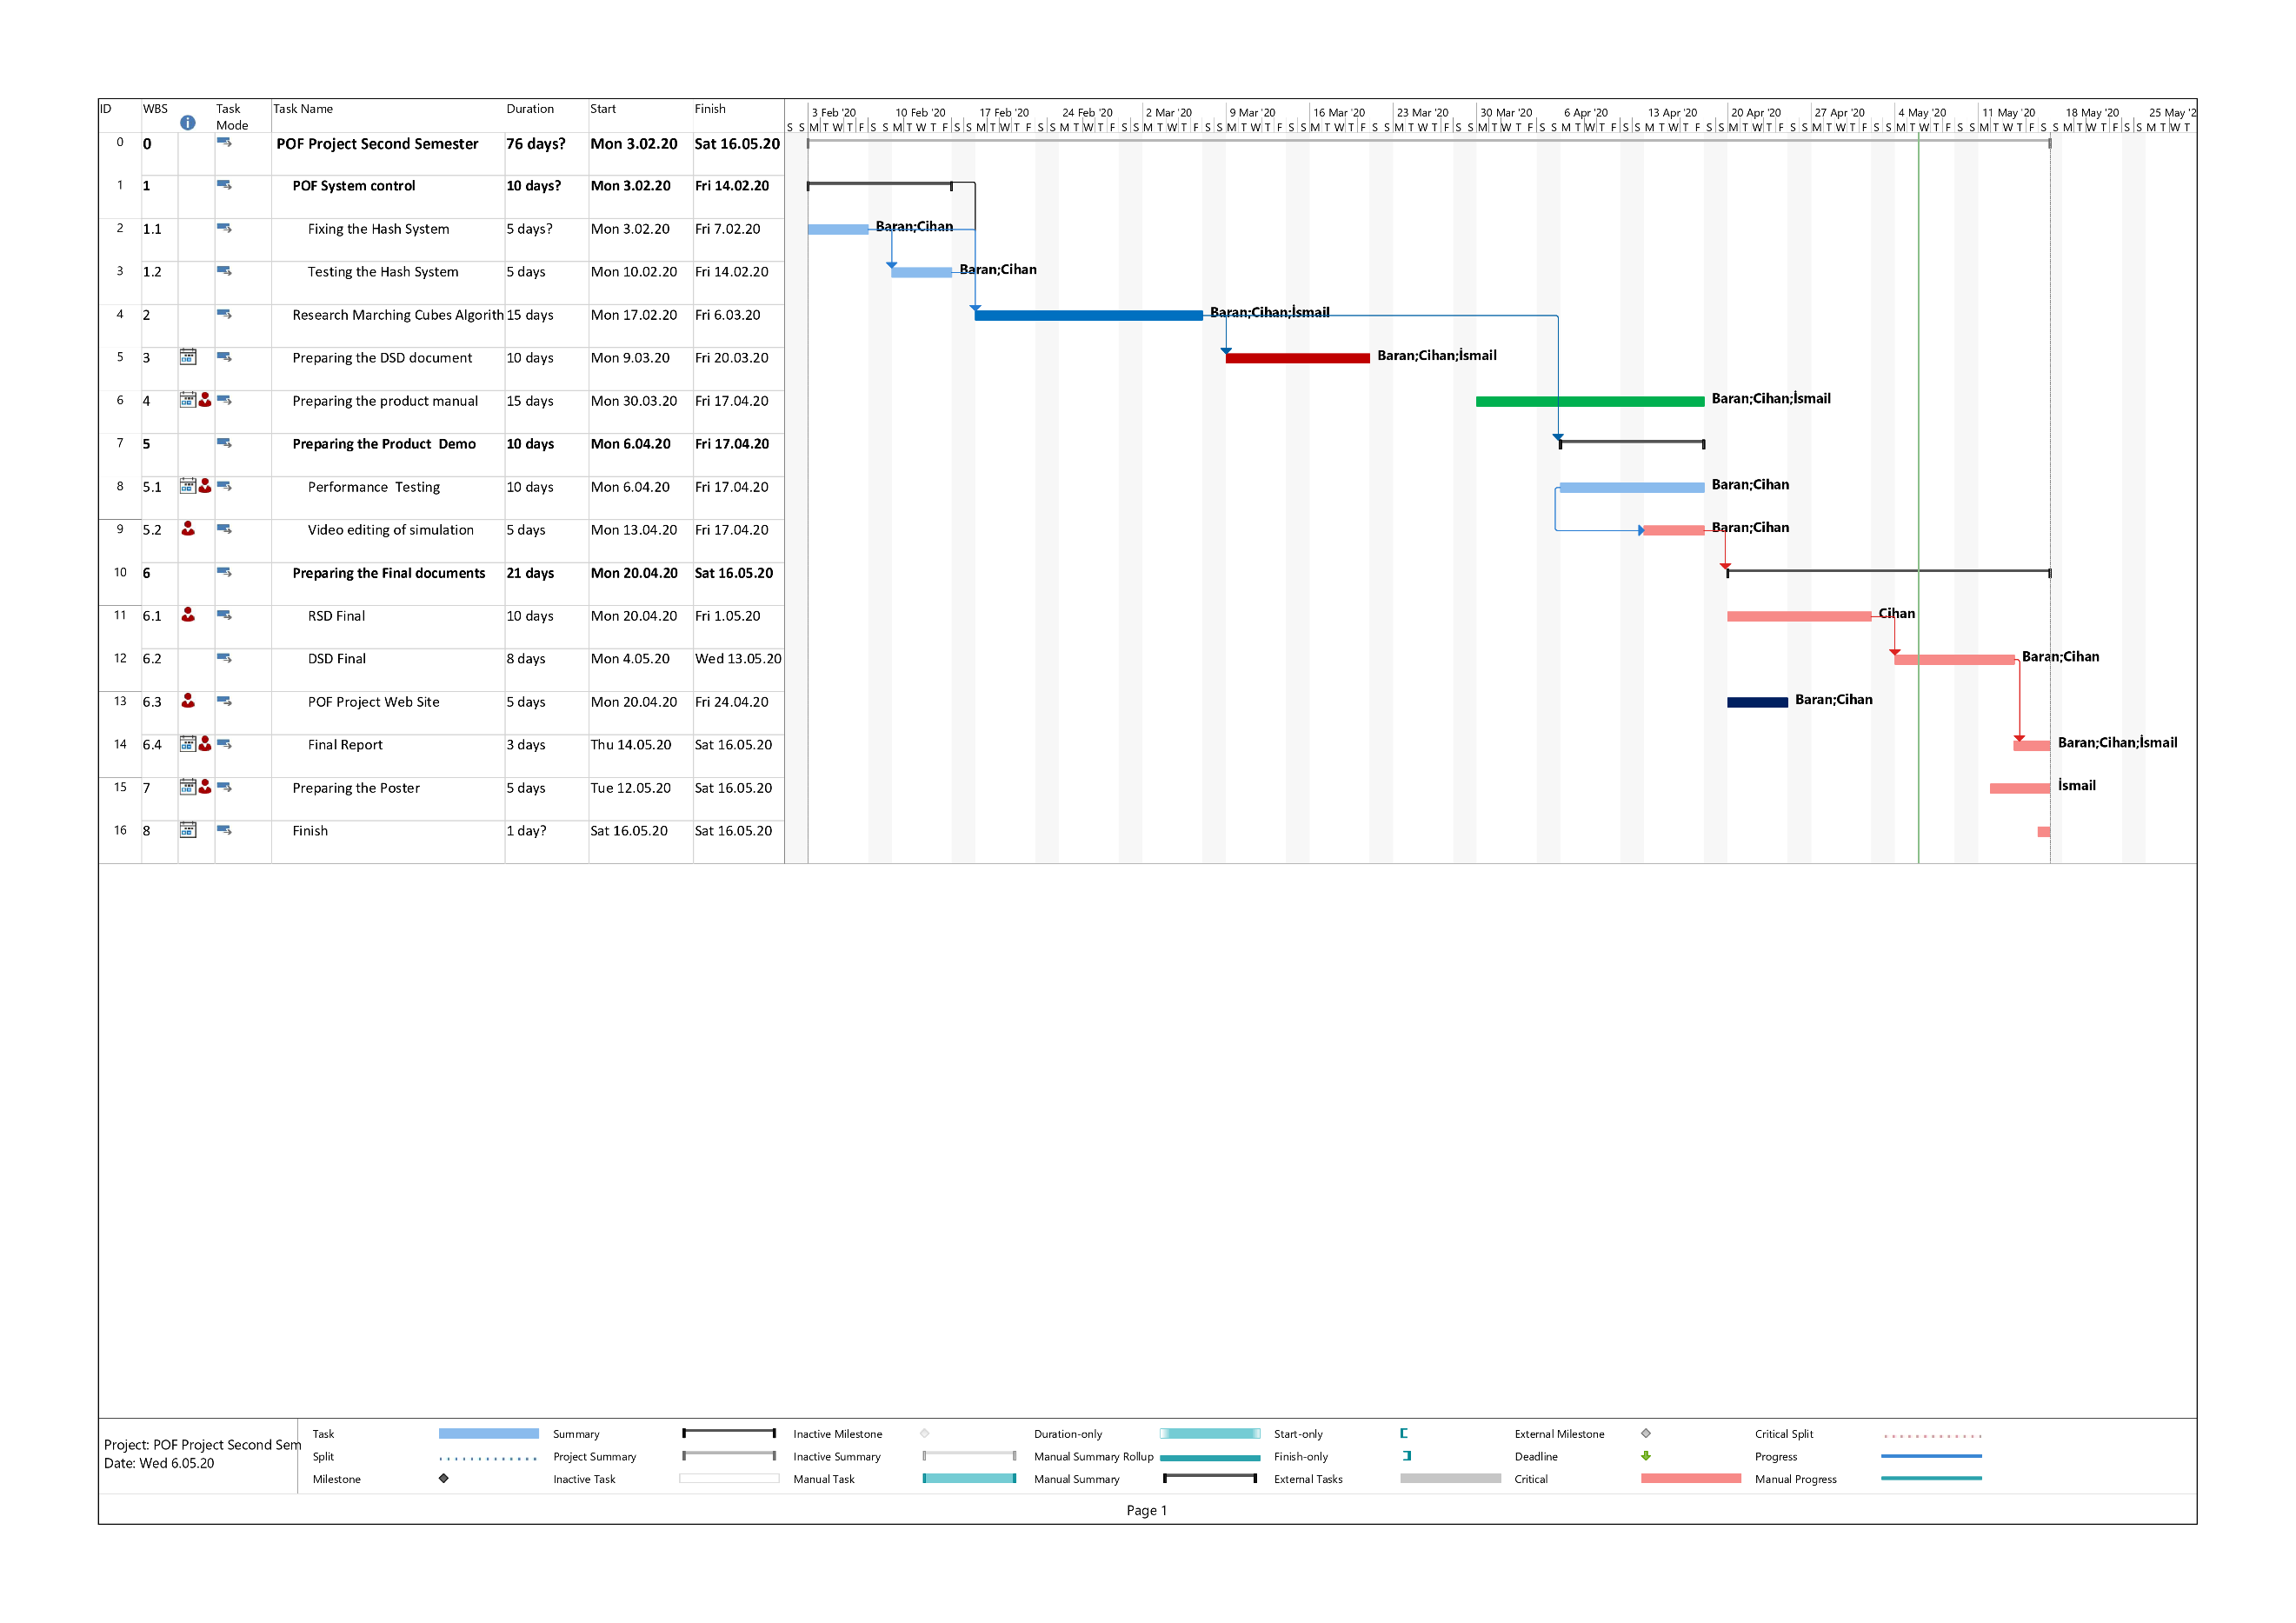

# 2. REQUIREMENTS

We discarded the last step of our project due to our access has inhibited to the computer laboratory in the university because of the COVID-19. We discussed with our project advisor and agreed on discarding the implementation of Marching Cubes algorithm requirement.

The final requirements of the project are provided in Appendix A: Requirements Specifications Document, revision 3.0 (RSD 3.0). All requirements are on the table below.

|  |  |
| --- | --- |
| **Requirement Type** | **Requirement Name** |
| Functional Requirement | Retrieve Particle Data |
|  |  |
| Functional Requirement | Divide into Cells |
| Functional Requirement | Surface Recognition |
| Functional Requirement | Marching Cubes |
| Non-Functional Requirement | Efficiency |
| Non-Functional Requirement | Performance |
| Non-Functional Requirement | Usability |
| Non-Functional Requirement | Testability |

**Table 3:** Requirements list.

# 3. DESIGN

This section describes about design of the POF system. High level and detailed designs are explained. Restrictions and conditions mentioned in this section.

# *3.1. High Level Design*

High level design is explained in detail and a sequence diagram is included in DSD 2.0.

***3.1.1. Class Diagram***

**Fig 1:** Class Diagram

The class diagram above explains classes and their attributes along with relations. NVIDIA flex is obligatory and an external source asset. Handler class is the main controller of the system. Handler communicates with classes transmit data to relevant classes.

Hash System class is responsible for the classification and finding particles. Particle Finder class returns the particle data such as position, particle id or particle's cell. Surface recognizer marks the surface particles when called.

Three classes on the top are related with Marching Cubes algorithm which is responsible for visualizing the particles in a different way. We wrote the Marching Cubes algorithm as a C# script in our project. However, we could not implement the Marching Cubes method into the POF system for obvious reasons (Please read warning page!). You can visit the design specifications document revision 3.0 (DSD 3.0) [2] for detailed explanations of class diagrams.

# *3.2. Detailed Design*

The detailed design part is mentioned in the DSD 3.0. In DSD 3.0 [2], detailed design is explained with activity diagrams of the POF system.

We explained those substructures as four parts of activity diagrams. First activity diagram is Marching Cubes Scalar Calculator which calculates the scalar value for the marching cubes algorithm. Second activity diagram is Surface Recognizer which determines the surface particles. Third activity diagram is Marching Cubes which analyses the surface vertices and decides which configurations of triangles will be sent to draw. Last activity diagram is Hash System which finds cell of a particle, cell id, particle id etc. Hash system is helping to find data briefly.

# *3.3. Realistic Restrictions and Conditions in the Design*

We neglected some aspects of the project on purpose to finish the project on time. The security problems are ignored because the project aims to help everybody who has interested fluid simulations and contribute to science. Normal computers are not capable of running the simulation fluently. User can not increase particle number without sacrificing the performance with normal computers. Simulation computer is required for this job. We assumed that users of the POF system have the necessary equipment and software and know-how to use them.

# 4. IMPLEMENTATION and TESTS

This section describes the tests and implementation stages of the POF system. Test results are discussed in the performance tests and results title. In the implementation of the POF system title, we shared important code snippets and explained the logic behind it.

# *4.1. Implementation of the POF System*

***4.1.1. Problems and Solutions***

Firstly, we had to recognize elements of NVIDIA flex, and then we discussed how to classify the particles and wrote the hash system. After, we research methods of identifying surface particles and discussed how to apply it. Last part we wrote a prototype code of the Marching Cubes algorithm to implement into POF system.

We explained how implementations made and code explanations in the product manual 1.0.

|  |  |
| --- | --- |
| **Main Problem** | **Solution of Problem** |
| Searching particle data linearly due to 3D space positions and vector3 to integer translation. | Spatial hashing algorithm provides reaching particles by put them into cell data. |
| Too many particles appear in simulations and handling all of them occurs performance problems. | Do not put into calculations inactive and unnecessary particle on visualization (surface particle finding algorithm). |
| Duplication of functions and similar methods. | We created a situational surface calculator class and particle finder classes to remove code duplication and increase the functionality of our code. |
| Increasing inter-community and data transmission complexity. | We constructed the Handler class which is responsible for all data transmission and user controls interface. |

**Table 4:** Problems and Solutions

***4.1.2 Implementation of Hash Algorithm***

We use a spatial hash algorithm to access the particle position easily. Hash algorithm simplifies the three dimensions of float particle positions to integer id numbers in a specific order.

Cube numbering starts from top left and from left to right and then top to bottom. Then it implies the same operation for the third dimension. On x dimension, we found cell id by subtracting minimum boundary area x from particle x, so it means that numbering increases from left to right. Same logic implies on y dimension, cell id number increase from top to bottom and similarly cell id number increases from backwards to forward in the z dimension.

We subtracted one from the xid, yid and zid when we are assigning an integer number because we initialize id numbering from zero. Cubex represents how many particles can be fit into the cell. We apply these calculations for all dimensions. We can reach cell id by position without storing it.



**Fig 2:** Cell ID Numbering

Vertex index struct represents cells by creating an array on this struct. We keep each vertex as 3d vector struct. We hold index point data in integer list.



**Fig 3:** Group Struct



**Fig 4:** Hash Size

We created cell ids as indices. By finding how many grids in each dimension we find our hash table size represented as figure 4. We find particles by looking at cells.

We have realized a problem occurs in this section during the implementation. If particle centre intersects with cell boundaries, we must decide to assign which particle will be in which cell. We solve this problem by logically assigning particle closest previous cell. If you imagine many neighbour cubes such as small cubes constructing a bigger cube such as 64 cubes, in the centre intersection point there are 8 possible cubic cells you can assign the intersecting particle. These if cells are looking for all intersecting possibilities for all dimensions. There are 2 to the power of 3 cases because of the spatial space we are dealing with. We did not share the whole code but give a snippet to make more understandable. If there is an intersection, we assign a previous cell. To give an example, let us assume a particle intersects with 2 cells. These cells are called cell id 1 and cell id 2. We assign particle to smaller cell id which is cell id 1.



**Fig 5:** Intersection Boundaries Check.

For example, in fig. 5. we found that particle on intersection boundaries and we found its second cell on y dimension

So that way we can find the particles by looking in cells instead of a linear search of the particles. The ceiling is implemented to derive integer numbers because particles are float and they are derived according to the AABB size.

***4.1.3 Particle Neighbour Algorithm***

We must find the effect of the particles in a range on a specific particle and calculate it for each particle. To think mathematically consistent and coherent with the particles, the shape of the volume that we are checking should be spherical. However, the required time and finish the project according to the given time interval has compelled project team to search cubical volumes. We must look at the hashed cell ids in the volume that we are searching to find neighbour particles.

We need four corner cells to solve the problem of finding neighbour particles.



**Fig 6:** Finding Corner Cells.

These three cell borders are called as tx, ty and tz.



**Fig 7:** Finding Dimensional Cell Count

We find grid intervals that cells are going towards in every dimension. So that way we can find all cells in this volume just by looking at one cell that we have grouped neighbour particles in that cell.



**Fig 8:** Finding Cell Numbers in Specific area.

***4.2 Performance Tests and Results***

These performance tests are made in the Unity platform to test our POF system and the performance of its subsystems. We have created a corridor with two obstacles (a capsule and a sphere objects) and released the particles (4096 particles) above a ramp. During the particles are moving in the test scene, we recorded surface recognition performance execution time frame by frame. We have recorded 100 frames and the particles go into a stable position rest of the frames in the scene. That is why we did not record after the particles are in halt position because it would not be correct measuring. The time per frame values could be wrong.

In the test scene, we aim to change the position complexity of the particles. So that why we could create a different combination of position data cases between particles and calculation parameters in the surface recognition system.

We divided the test scene into five phases. The initial position of the test scene is called perfect cube phase as you can see in the figure below. When the user pressed the play button, the particle set will be released, and particles will scatter. Inner particles are painted to blue.

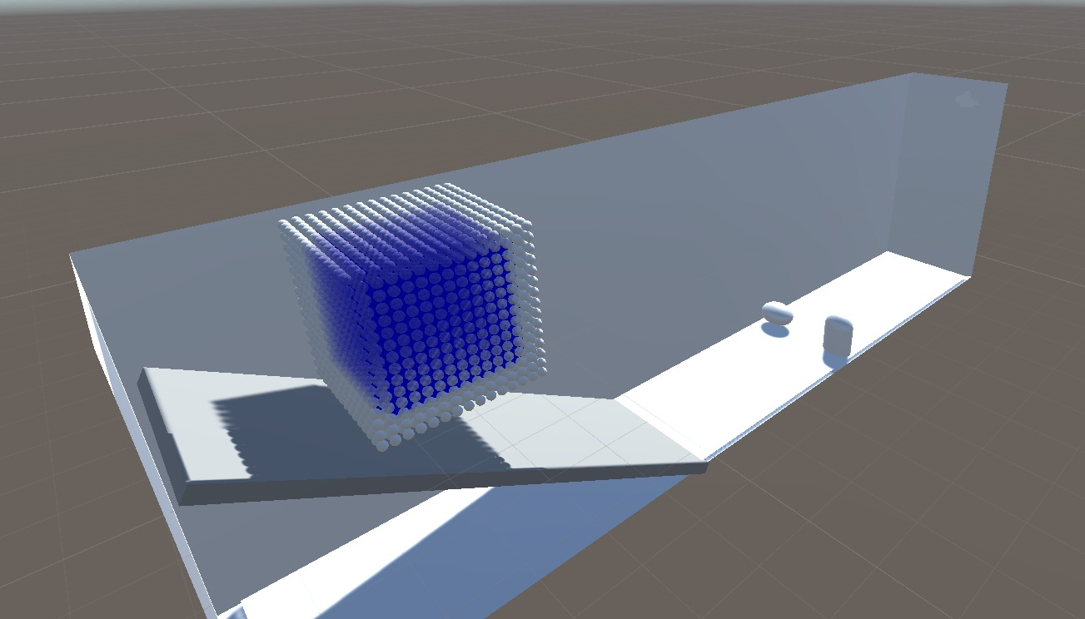

**Fig 9:** Particles in Perfect Cube Form.

The particles released (4096 particles) and moving downwards through the ramp and complexity of particles is increasing. The particles have approached one another and particle number in a cell is increased. That means more calculation when calculating the weight of a particle and it increases the execution time of the surface recognition.

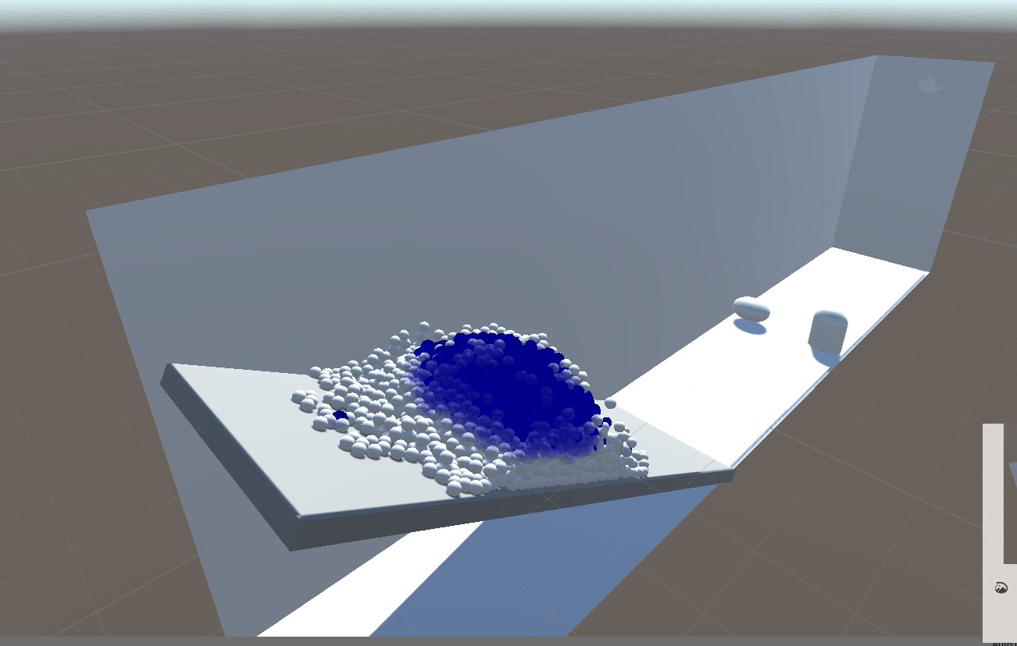

**Fig 10:** Particles on Ramp.

Particle complexity is decreasing between the ramp and obstacles because particles are just moving forward. When the particles crashed to the obstacles, complexity is increasing. Especially the particles that accumulate in front of the obstacles. These particles are approaching one another but the rest of the particles are going from the middle of the corridor floor.

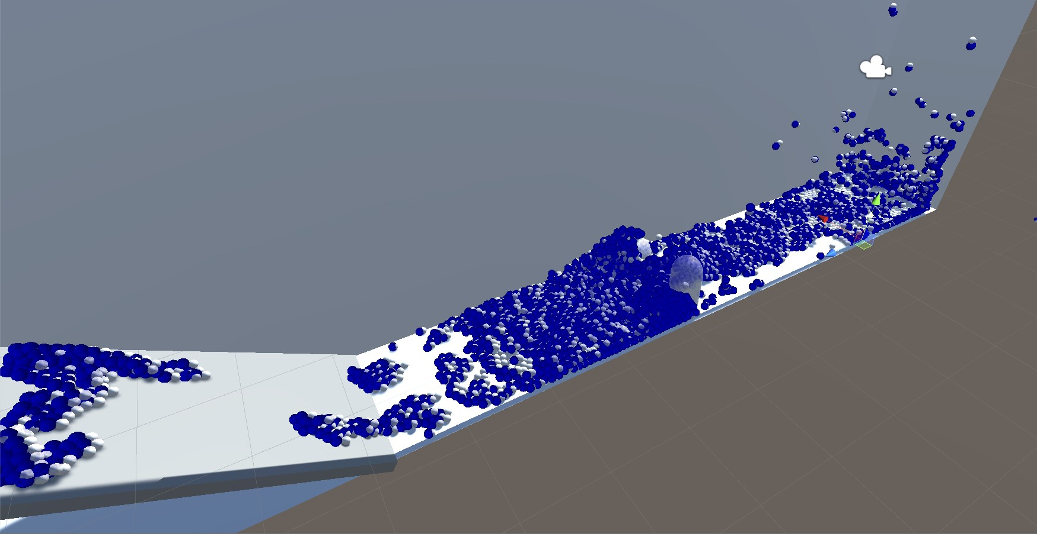

**Fig 11:** Particles are Crashing to Obstacles.

After the crashing of the particles to the sphere obstacles, particle speed is decreasing, and the other particles position is getting stabilized. That means complexity is decreasing again and surface execution takes less time because of the less computational load.

We deduced the first hundred frame of the scene that we explained, and this is the chart of the surface recognition time per frame chart. We divided a hundred frames of test scene into five phases. As you can see from the chart, the initial execution time is about 700 milliseconds and increasing when moving on the ramp. When the particles pass the ramp and moves through the sphere and capsule obstacles, complexity is decreasing exponentially. At the moment of particles collide with obstacles, particle complexity is increasing, and execution take more time. After the particles pass obstacles in the last phase, particle complexity is decreasing, and surface execution is getting faster.

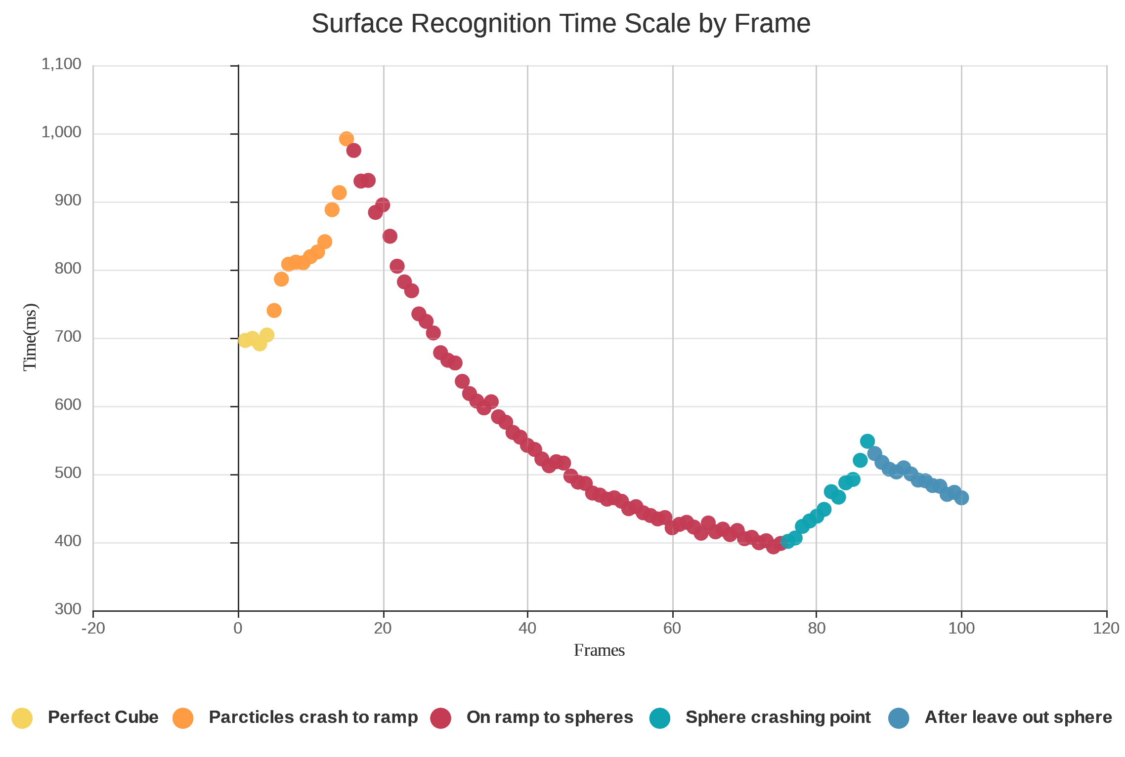

**Fig 12:** Surface Recognition Time Scale by Frame Chart

We prepared another test measuring scale as particle number. We could not increase the particle numbers more than four thousand due to lack of simulation computer. So, we decided four test cases: One thousand, two thousand, three thousand and four thousand and ninety-six particles.

We decided that measuring the first sixty frames of every particle cases is enough for the testing. We did not change the test scene so we can expect the same results of the previous chart with 4096 particles. The other lines of the different particle numbers are very similar to the yellow line that represents 4096 particles. However, in this test scene we measured 60 frame and that means we did not include particles are colliding to the obstacles phase so that little spike at the right of the chart is not exist compared with the previous chart.

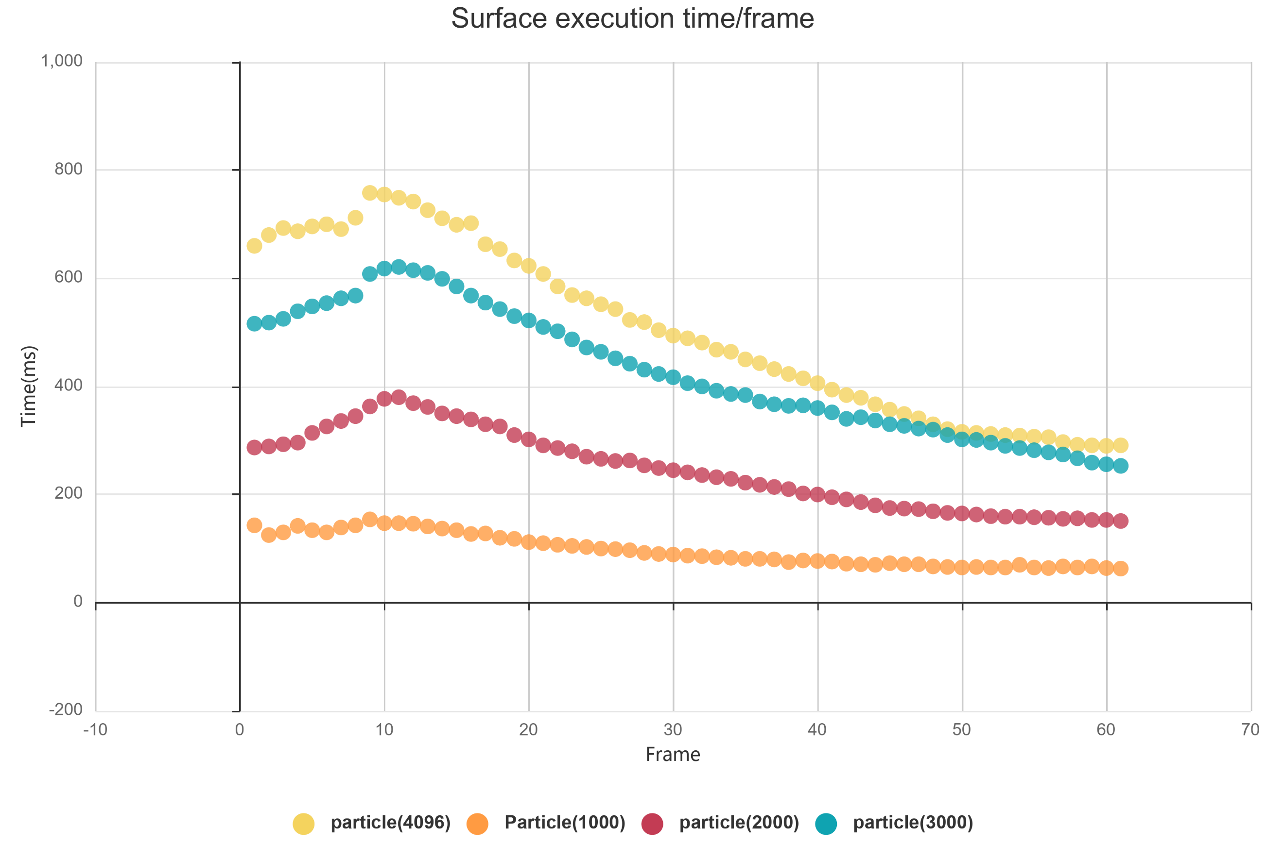

**Fig 13:** Surface Recognition by particle number comparison chart.

# *4.3. Environment Testing*

In this section, we explained why we decided to use NVIDIA Flex and compared to other particle-based fluid simulations.

***4.3.1 Availability of the Necessary Environment***

We have tested three particle-based fluid simulation before deciding to use NVIDIA Flex and we disqualified other assets. We stated the reasons for the table below.

|  |  |
| --- | --- |
| **Name** | **Description** |
| uFlex | We had small bugs and errors in the code, even though we have fixed minor bugs, the particles were not recognizing the collider of the objects. Collider of the simple primitive objects was not recognized by the Uflex and particles were penetrating the objects. The only plane object was being recognized by the uFlex. The problem could not be solved, and we have changed the fluid simulation. |
| Obifluid | We eliminated the Obifluid because of performance problems. The expected result was not satisfied by the Obifluid compared to other fluid simulations. Our expectation was reaching 30fps with a hundred thousand particles, but we obtained 3 fps in a scene with three thousand particles. |
| Screen Space Fluids Pro | We encountered bugs and errors in the code like uFlex. Although we fixed bugs, the performance was very low on higher particle count compared to NVIDIA Flex. |

**Table 5:** Environment Availability.

To give an overview of the test results of the product manual, we showed with images that components of the POF systems operates correctly. Hash System and Surface Recognizer components proved that operating without any problems. In DSD 3.0, we mentioned the working prototype of Marching Cubes code however it will not be implemented into our project. Other test results are included in the product manual revision 1.0 (PM 1.0).

# 5. CONCLUSIONS

In this section, we summarize our project by explaining the project goals and how we achieved it. We give cost analysis of workers, software, and hardware. We described the benefits of the POF system and fields of usage. Lastly, we reviewed future works as further developments on the project.

# *5.1. Summary*

We stated our requirements in RSD 3.0 [1]. Generally, our requirements were increasing performance and efficiency. Functional requirements except for the last part which is the implementation of Marching Cubes algorithm. The excuse is explained in the warning title page 8.

The non-functional requirements are not completely met because we could not finish the project. If we could have finished the last step. There would be tangible proof that all requirements fully met. The marching cubes algorithm would vastly decrease the workload on a GPU. Because drawing and rendering millions of sphere particles instead of drawing triangles to covering the surface vertices take so much time.

# *5.2. Cost Analysis*

In this section we separated project schedule as first and second semester.

***5.2.1 Cost Analysis of First Semester***

First-semester cost analysis involves the cost of workers, software, and hardware. Besides, we shared the ideal hardware components of the simulation computer after the table of the system that we used.

***5.2.1.1 Cost of Workers***

|  |  |  |  |  |  |  |
| --- | --- | --- | --- | --- | --- | --- |
| **Members** | **Day/Hour** | **Week/Hour** | **Semester/Hour** | **Salary/Hour** | **Salary/Monthly** | **TOTAL** |
| Member | 8 | 40 | 560 | 30 TL | 4800 TL | 16800 TL |

**Table 6:** 1. Semester Cost of Workers.

As shown in the cost analysis table, three people works in the project. Every people work equally as workload. Therefore, only one member is represented on the cost table.

Every member works 8 hours a day and 5 days a week. A semester consists of 14 weeks and salary is 30 Turkish Lira per hour. Each member costs 4800 TL per month and costs 16800 in a semester. The salary costs of all three members are 50400 TL per semester. The equivalent of 16800 TL is $2894, 67. Currency translation has made from Dollar / Turkish Lira = 1 / 5.80 on 10 December 2019.

***5.2.1.2 Cost of Software***

|  |  |
| --- | --- |
| **Title of Software** | **Cost** |
| uFlex | $30 |
| Obi Fluid | $30 |
| SSF | $7 |
| **Total Cost** | **$67** |
|  |  |

**Table 7:** Cost of software

***5.2.1.3 Cost of Hardware***

***5.2.1.3.1 PC components that used in Project***

Total cost = Total employee cost + Total software cost + Total Hardware cost (PC1)

|  |  |
| --- | --- |
| **PC 1 components that used in Project** | **Description** |
| Operating System | Windows 10 (64-bit) |
| Processor | Intel Core i7-4700 HQ CPU |
| Memory | 16 GB RAM – DDR3L-1600 MHz |
| GPU | NVIDIA GeForce GTX850M 4GB DDR3 |
| Cost of PC 1 per user | $1693, 21 |
| **Total cost (for 1 worker)** | **$4684, 88** |
| **Total cost (for 3 workers)** | **$14054, 64** |

**Table 8:** Cost of PC1

***5.2.1.3.2 Optimal Simulation Computer (PC 2)***

Total cost = Total employee cost + Total software cost + Total Hardware cost (PC2)

|  |  |
| --- | --- |
| **Optimal Simulation Computer (PC 2)** | **Description** |
| Operating System | Windows 10(64-bit Pro) |
| Processor | 8-core Intel i7 5.1 GHz |
| Memory | 32 GB RAM- DDR4- 2666MHz |
| GPU | NVIDIA Quadro P2200 5GB |
| Cost of PC 2 per user: | $5017 |
| **Total cost (for 1 worker)** | **$8008,67** |
| **Total cost (for 3 workers)** | **$24026,01** |

**Table 9:** Component costs of PC2

***5.2.2 Cost Analysis of Second Semester***

In this section cost of workers and hardware tables are given. There is no cost of software and hardware table because we did not spend money on software and hardware on the contrary of the first semester.

***5.2.2.1 Cost of workers***

In this semester, we could not continue to project code implementations since the university is closed in the middle of March. We spend our working time by completing document work and preparing other materials. Therefore, the cost of workers in April and May is lower than general because we spent fewer hours for obvious reasons. Calculations are made for each month and each member.

|  |  |  |  |  |  |  |
| --- | --- | --- | --- | --- | --- | --- |
| **Month** | **Day/Hour** | **Workday/Month** | **Month/Hour** | | **Salary/Hour** | **Salary/Monthly** |
| February | 8 | 20 | 160 | | 30 TL | 4.800 TL |
| March | 8 | 22 | 176 | | 30 TL | 5.280 TL |
| April | 4 | 21 | 84 | | 30 TL | 2.520 TL |
| May | 4 | 14 | 56 | | 30 TL | 1.680 TL |
| **Total Salary (for 1 member) = 14.280 TL** | | |
| **Total Salary = 42.840 TL** | | |

**Table 10:** 2. Semester Cost of Workers

# *5.3. Benefits of the Project*

In this section, we listed the areas that we can think about. It could be more areas that our project can benefit.

* + 1. ***Animations and Movies:*** The POF system can be used in any movies, animations that used fluids.
    2. ***Scientific work:*** Our project benefits scientific areas the most because the project is heavily research and development based on the research papers about the particle-based fluid simulations. Scientist and researchers can use the POF system for their scientific research.
    3. ***Games:*** Games can necessitate a fluid simulation system to make more realistic games. The POF system can be used to obtain more realistic games. For instance, a sailing simulator game is a viable option for our system.
    4. ***Construction:*** The construction and Architecture areas can benefit from our system because the simulation is physics-based which means the POF system is almost realistic. The POF system neglects some imperceptible elastic deformations. For instance, a civil engineer can build a barrage and want to test endurance, on the computer simulation. Therefore, our system can be used for construction and architecture testing.

# *5.4. Future Work*

The first thing to do is implementing the Marching Cubes algorithm and later research algorithms to make the visual output more fluid-like. More research papers can be implemented to the POF system and discuss the results for future work.

# References

1. Requirement Specifications Document revision 3.0 (RSD 3.0).
2. Design Specifications Document revision 3.0 (DSD 3.0)**.**
3. Product Manual revision 1.0 (PM 1.0).
4. **[WH87]** William E. Lorensen and Harvey E. Cline. (1987). Marching cubes: A high resolution 3D surface construction algorithm. ACM SIGGRAPH Computer Graphics. 21, 163-169.
5. **[ZB05]** Zhu, Y., & Bridson, R. (2005). Animating sand as a fluid. (New York, NY, USA, 2005) ACM Trans. Graph., 24, 965-972.
6. **[KBSS01]** Kobbelt, Leif & Botsch, Mario & Schwanecke, Ulrich & Seidel, Hans-Peter. (2001). Feature sensitive surface extraction from volume data. Proceedings of the ACM SIGGRAPH Conference on Computer Graphics. 10.1145/383259.383265.
7. **[AIAT81]** G. Akinci, M. Ihmsen, N. Akinci, and M. Teschner. 2012. Parallel Surface Reconstruction for Particle-Based Fluids. Comput. Graph. Forum 31, 6 (September 2012), 1797–1809. DOI:https://doi.org/10.1111/j.1467-8659.2012.02096.x

**APPENDICES**

**APPENDIX A: REQUIREMENTS SPECIFICATIONS DOCUMENT**

**APPENDIX B: DESIGN SPECIFICATIONS DOCUMENT**

**APPENDIX C: PRODUCT MANUAL**